Predicting Cancer Mortality Rate and Stroke Occurrence: A Comparative Machine Learning Analysis for Healthcare Decision-Making
Allen Gao
University of Massachusetts Amherst
MIE622
Michael Prokle
Executive Summary
This report evaluates whether two preliminary datasets supplied by a Boston Hospital could support machine-learning applications for cancer mortality prediction and stroke risk classification. Three regression models were evaluated for the cancer dataset, while two classification models were evaluated for the stroke dataset. All of the models were compared using the same testing samples.
Out of all three regression models used for the cancer dataset, Gradient Boosting produced the strongest cancer mortalitiy rare results, with a testing R^2 of .483, an MAE of 15.31, and an RMSE of 20.50 deaths per 100,000 people. These results represented moderate predictive performance, and the model exhibited some overfitting. Cancer incidence rate was the most influential measured predictor, although the dataset lacked important clinical information such as cancer type, stage, and treatment.
Both stroke models achieved 95.24% testing accuracy, but this result was misleading because most observations were no-stroke cases. Logistic Regression identified only 3 of the 75 actual stroke cases, while the MLP Classifier identified only 2. Neither model demonstrated sufficient stroke recall for clinical screening or diagnosis.
Based on these preliminary results, while stroke had the highest accuracy, the company should pursue the cancer use case first. The reason why is that stroke’s result was inflated by a large number of no-stroke observations, and the model correctly identified only 3 and 2 of the 75 actual test stroke cases. In comparison, the cancer models demonstrated moderate but more meaningful predictive performance and could provide greater practical value for community-level planning and resource prioritization.
Introduction
A Boston healthcare company has partnered with a local hospital to explore how machine learning could support efforts to address cancer and stroke, two major contributors to mortality. The hospital provided two preliminary datasets containing community-level cancer mortality information and individual-level stroke information. This analysis develops and compares regression models for predicting cancer mortality rates and classification models for predicting stroke occurrences. It also examines the most influential measured predictors, evaluates each model’s performance and limitations, and considers the practical relevance of the results. The final objective is then to recommend which of the two healthcare use cases the company should pursue first based on the quality of the preliminary data and the model’s ability to produce useful predictions.
Data Cleansing
The first step was to examine both datasets for missing values, duplicate records, placeholder values, and clearly invalid observations. Neither dataset had any duplicated rows or question-mark placeholders. However, approximately 75% of the values in PctSomeCol18_24 were missing. In addition, PctEmployed16_Over contained 152 missing values, while PctPrivateCoverageAlone contained 609. Because most of the values in PctSomeCol18_24 were unavailable, the predictor was removed when separating the target value from the predictors for the Cancer dataset. The stroke dataset also contained 201 missing BMI values. Once the missing data were identified, the cancer dataset’s column names were standardized by removing surrounding spaces, converting all letters to lowercase, and replacing spaces with underscores. This created a consistent naming format and made the variables easier to reference throughout the analysis. In the stroke dataset, the ever_married variable was converted to binary values, with “No” represented by 0 and “Yes” represented by 1. This conversion allowed marital status to be used directly as a numerical predictor while preserving the meaning of its two categories. The “Unknown” values in the smoking_status variable were relabeled as “not reported.” These observations were retained as a separate category because the patients’ actual smoking histories were unavailable and could not be reliably inferred from the other data. The remaining categorical variables in the stroke dataset were transformed through one-hot encoding. This process created a separate binary indicator for each category so that the classification models could use the information numerically. The cancer dataset was also examined for anomalous median-age values. Thirty observations fell outside the selected plausible range of 18 to 100 years and were treated as data errors. Each invalid value was replaced with the average of the corresponding community’s male and female median ages, allowing the observation to be retained while using information from the same community so that it doesn’t negatively impact the models when used.
Each dataset’s target variable was separated from its predictors. The target_deathrate column served as the continuous target for the cancer analysis, while the stroke column served as the binary target for the stroke analysis. The race variables in the cancer dataset, such as pctblack and pctasian, were removed because using ethnicity to predict cancer mortality would raise fairness and ethical concerns. The male and female median-age variables were used to correct the invalid overall median-age observations and were then removed from the predictor set. Because the overall median-age variable was retained, including all three age measurements would have provided redundant information and could have increased multicollinearity. The geography variable was removed because it contained many unique county and state labels and served more as a location identifier than as a generalizable predictor. One-hot encoding this variable would have created numerous additional columns and increased the risk that the models would memorize location-specific patterns rather than learn relationships that could apply to new communities. The binnedinc was redundant, as it represented the income ranges that were captured accurately by the medIncome variable, which got it removed. The avghouseholdsize and birthrate variables were also removed because the preliminary review indicated that they had limited relevance to predicting cancer mortality rates in this dataset. The avgdeathsperyear variable was removed because it directly measured the number of annual cancer deaths and was therefore closely related to the cancer mortality-rate target. Including it could have introduced target leakage. For the stroke dataset, only the id was removed, as it is just a unique identifier for each patient and did not contain meaningful demographic or clinical information.
Once the target variables were separated and unsuitable predictors were removed, both datasets were divided into 70% training and 30% test data using a random state of 42 to make it reproducible. The split was also stratified by the stroke target, preserving approximately the same proportion of stroke and no-stroke observations in both samples so that the model doesn’t become less reliable. This was particularly important because stroke cases represented only a small percentage of the dataset and no-stroke cases represented a larger proportion. Stratification ensured that the testing sample remained representative of the original data and contained enough stroke cases for a more reliable model evaluation. The median of each numerical predictor was calculated separately from the training data. Missing values in both the training and testing samples were then replaced with the corresponding training-set median for that column. This approach prevented information from the testing data from influencing the preprocessing process and reduced the risk of information leakage. Once there were no missing data, the continuous numerical predictors in both datasets were standardized using StandardScaler, which transformed them to have a mean near zero and a standard deviation near one. This placed the predictors on comparable scales and prevented variables measured with larger numerical values from exerting disproportionate influence on the logistic-regression and neural-network models. The scaler was fitted using each training dataset and then applied to its corresponding test dataset to prevent information leakage. Binary predictors were excluded from standardization so that they remained coded as zero or one.
Cancer dataset and Model Analysis
Because the cancer target represented a continuous mortality rate, regression methods were selected for this analysis. A Gradient Boosting model was used because it can capture nonlinear relationships and interactions among socioeconomic, educational, and healthcare-related predictors. It builds a sequence of decision trees in which each new tree attempts to correct errors made by the previous trees. An MLP Regressor was also developed as a neural-network benchmark capable of identifying complex patterns in the standardized predictors and taking in a large amount of data inputs. Finally, an OLS regression was evaluated as a simpler and more interpretable alternative. The Gradient Boosting model was configured with 90 decision trees, a learning rate of .05, and a maximum tree depth of three. The shallow trees limited the complexity of each learner, while the low learning rate allowed each tree to make a small, gradual correction to the errors produced by the preceding trees. These settings were selected to balance predictive performance with the risk of overfitting, and a random state of 42 was used to make the results reproducible. The MLP Regressor used one hidden layer containing 90 neurons and the ReLU activation function to learn nonlinear relationships within the cancer data. Stochastic gradient descent was used to update the network’s weights with an initial learning rate of .0005. An alpha value of .10 provided regularization to reduce overfitting, and the model was allowed a maximum of 2,500 iterations. Early stopping reserved 15% of the training data for validation and stopped training after 30 consecutive iterations without improvement. A random state of 42 was also used to make the results reproducible. All cancer models were trained using the same training predictors and mortality-rate outcomes. After training, each model generated predictions for the same testing dataset, which had not been used during model fitting. Using identical training and testing samples provided a fair comparison of the models. Their performance was evaluated using training and testing R^2, the R^2 gap, testing MAE, testing RMSE, and computation time.
After all performance measures were evaluated, the three cancer models demonstrated moderate rather than strong predictive performance, as shown in Figures A1, A2, and A4. Testing R^2 values ranged from .458 to .483, indicating that the models explained approximately 45.8% to 48.3% of the variation in cancer mortality rates while leaving more than half unexplained. Gradient boosting achieved the highest testing R^2 of 48.3% and the lowest MAE and RMSE, at 15.31 and 20.50 deaths per 100,000 people, respectively. However, its training–testing R^2 gap of 18.4 was substantially larger than the OLS gap of 5.5 and the MLP gap of 10.2, indicating greater overfitting. Although Gradient Boosting was the slowest of the three models, its computation time was still relatively short and would be unlikely to create a meaningful operational burden. Its higher testing R² and lower prediction errors therefore outweighed the additional computation time, although its larger training–testing gap should still be considered because it indicated greater overfitting. Figure A1 shows that many predictions followed the general direction of the perfect-prediction line, but considerable dispersion remained around the middle of the graph. This indicates that the models captured the overall relationship between the predictors and cancer mortality but still produced substantial errors for some individual communities. To determine which measured factors had the greatest influence on the predictions, permutation importance was computed on the test data. This method randomly permuted the values of each predictor and measured the extent to which the model’s performance declined. Predictors that produced larger decreases in performance were considered more influential, as shown in Figure A3. Cancer incidence rate was the most influential predictor across all three models, increasing testing MAE by approximately 3.7 deaths per 100,000 when shuffled. The percentage of married households and private health insurance coverage were also influential for the OLS and MLP models, while educational attainment measures were more influential for Gradient Boosting. The models’ heavy reliance on cancer incidence rate, combined with the relatively small contributions of many other predictors, may partly explain their moderate predictive performance. Incidence rate indicates how frequently cancer is diagnosed, but it does not capture differences in cancer stage, treatment effectiveness, survival, or other clinical factors that directly influence mortality.
Overall, one major limitation was that the dataset primarily contained community-level socioeconomic, educational, and healthcare-coverage measures rather than direct clinical information. Important factors such as cancer type, stage at diagnosis, treatment received, and other cancer-related factors could serve as stronger predictors, replacing some existing ones and improving the model’s ability to predict the cancer mortality rate. Another shortcoming was that some models, particularly Gradient Boosting, had relatively large training–testing accuracy or R^2 gaps, indicating overfitting. The models performed better on training data than previously unseen testing data, suggesting that they learned patterns specific to the training observations that may not generalize to other communities. Repeated cross-validation, additional hyperparameter tuning, reduced model complexity, and more complete data related to cancer could help reduce this problem.
The models have some practical relevance as population-health planning tools. The predicted mortality rates could help the company identify communities that may require additional cancer screening, prevention programs, and other measures to reduce the cancer mortality rate. The results could also help managers to prioritize communities in which limited funding and personnel may be most needed. However, because the predictions are based on community-level data and have only moderate accuracy, they should be used as supporting evidence rather than as the sole basis for resource-allocation or patient-care decisions. Future versions of the cancer models could be improved by collecting more recent and complete data containing cancer-specific clinical, behavioral, screening, and treatment information. Repeated cross-validation and additional hyperparameter tuning could provide more reliable estimates of performance and reduce overfitting
Stroke Dataset and Model Analysis
Because the stroke target was represented as a binary outcome-stroke or no stroke-classification methods were selected for this analysis. Logistic Regression is a classification method that was used as a simple and interpretable baseline because it estimates the probability that a patient has a stroke or not. It was also selected as an interpretable baseline against which the more complex MLP classifier could be compared. The MLPClassifier model was selected because it can learn complex, nonlinear relationships and interactions among the measured stroke risk factors that Logistic Regression may not capture. It also provided a more flexible neural-network benchmark against which Logistic Regression could be compared.
The Logistic Regression model used liblinear because it is efficient and well suited for binary classification with a small to medium-sized dataset. The MLPClassifier had a hidden layer containing 90 neurons to give the network enough flexibility to learn nonlinear relationships while limiting unnecessary complexity and computation time. The hidden-layer activation function was adjusted manually during exploratory model tuning. Among the activation functions evaluated, logistic produced the highest observed overall accuracy and was therefore retained for the final MLP Classifier. As the MLP Regressor used for the cancer dataset, the stroke MLP Classifier used stochastic gradient descent to update the network’s weights during training. However, the stroke model used a higher initial learning rate of .05, which allowed larger weight adjustments during each training iteration. The MLP Classifier was allowed a maximum of 15,000 training iterations, providing sufficient opportunity for the network to converge. The model could stop earlier if it satisfied its convergence criteria. Both stroke models used a random state of 42 to make their results reproducible. Once the models were configured, an evaluation loop trained each model using the same stroke training data. Each fitted model generated stroke probabilities for the training and testing samples, and the selected probability threshold of .39 converted those probabilities into stroke or no-stroke predictions. The loop then calculated training and testing accuracy, the accuracy gap, confusion-matrix counts, and computation time. Testing predictions were also stored so that the confusion matrices and classification reports could be created consistently for both models.
The results of the models showed similar overall accuracy. Both Logistic Regression and the MLP Classifier achieved a testing accuracy of 95.24%. Logistic Regression achieved a training accuracy of 95.08%, while the MLP Classifier achieved 95.14%, resulting in small training–testing gaps for both models. However, these high accuracy scores were largely influenced by the class imbalance because most of the testing observations represented no-stroke cases. Therefore, accuracy alone did not demonstrate whether the models could reliably identify actual stroke cases. As shown in the model-results table in Figure A5 and the confusion matrices in Figure A6, both models classified no-stroke observations accurately but failed to identify most actual stroke cases. Logistic Regression would be preferred over the MLP Classifier despite having the same testing accuracy and a slightly larger accuracy gap. Its gap was still very small, and it achieved higher stroke recall and F1-score by correctly identifying 3 stroke cases compared with the MLP’s 2. Logistic Regression also required less computation time. However, because it still missed 72 of the 75 stroke cases, it should be considered the better preliminary benchmark rather than a model ready for clinical use.
To check what could have driven these predictions, permutation importance was applied to the testing data using ROC-AUC as the scoring metric. ROC-AUC was selected because it evaluates the models’ ability to distinguish stroke from no-stroke cases without depending on the manually selected probability threshold or the imbalanced class proportions. Each predictor was shuffled 20 times, and larger decreases in ROC-AUC indicated greater predictive importance; their importance rankings are presented in Figure A7. Age was by far the most influential predictor for both, indicating that both models relied heavily on age when distinguishing stroke from no-stroke observations in this preliminary dataset. The importance values of the remaining predictors were substantially smaller, suggesting that they provided much less predictive information. However, it doesn’t establish that age directly caused the observed strokes, though. This could lead people to focus on people’s age to help determine whether or not people have strokes in the primary datasets, but it should not be used by itself to determine whether a person experienced a stroke, as the current model failed to detect most stroke cases.
To examine why the models achieved such high overall accuracy while missing most actual stroke cases, the distributions of their predicted probabilities were compared by actual outcome, as shown in Figure A8. Figure A8 was created by plotting the distribution of predicted stroke probabilities for observations that actually experienced a stroke and those that did not. The dashed line represents the selected classification threshold of .39. Although actual stroke cases generally received higher predicted probabilities than no-stroke cases, the two distributions overlapped considerably, and most actual stroke cases remained below the threshold. This helps explain why both models achieved high overall accuracy while missing most actual stroke cases: most stroke cases received probabilities below the .39 threshold, and their probability distributions overlapped substantially with those of no-stroke cases. Meanwhile, correctly classifying the much larger no-stroke group dominated the overall accuracy score. Lowering the threshold could improve stroke recall by identifying more actual strokes, but it would also increase false-positive predictions and reduce overall accuracy.
Looking across these models, one major shortcoming is that, while both achieved high overall accuracy, they failed to identify most actual stroke cases. The severe class imbalance caused accuracy to overstate their usefulness because correctly predicting the much larger no-stroke group concealed their extremely low stroke recall. Although the models were highly effective at classifying no-stroke observations, they performed poorly at identifying actual stroke cases—the outcome that would be most important in a healthcare screening application. One way to improve the models would be to collect more observations involving actual strokes because the limited number of positive cases restricted the models’ ability to learn patterns associated with stroke. Another improvement would be to include additional clinically relevant predictors, such as blood-pressure measurements and cholesterol levels. These variables may help the models distinguish stroke cases more effectively from no-stroke cases.
Overall, the models have some practical relevance as a preliminary stroke risk-assessment and research tool. They could help the company examine patterns in the available patient characteristics, identify factors associated with elevated predicted stroke risk, and provide a baseline against which future models could be compared. Of the two models, Logistic Regression would be the more practical preliminary choice because it achieved higher stroke recall and F1-score, correctly identified one additional stroke case, and required less computation time than the MLP Classifier. However, neither model should currently be used for clinical screening or diagnosis because both missed nearly all actual stroke cases. Substantial improvement and validation with more representative clinical data would be required before either model could support patient-care decisions.
Conclusion
In the end, both datasets provided useful preliminary insights, but neither produced a model that should be used as a standalone healthcare decision-making tool. The cancer Gradient Boosting model demonstrated moderate predictive performance and could identify communities that may require additional screening, prevention programs, or healthcare resources. In contrast, the stroke models achieved high overall accuracy but failed to identify nearly all actual stroke cases. The severe class imbalance allowed correct predictions for the much larger no-stroke group to dominate the accuracy score and conceal the models’ extremely poor stroke recall, which substantially limited their practical usefulness.
Based on these results, the company should pursue the cancer use case first as a population-health planning application. Its predictions were more meaningful and operationally useful because the cancer models captured a moderate relationship between the available community-level factors and mortality rates. However, these predictions should be used only as supporting evidence for community planning and resource-allocation decisions. The cancer model would require stronger clinical predictors and additional cross-validation before operational deployment. The stroke use case should remain in development until more stroke cases, clinically relevant predictors, and imbalance-aware modeling methods become available.

Appendix
Figure A1
Actual Versus Predicted Cancer Mortality Rates by Regression Model
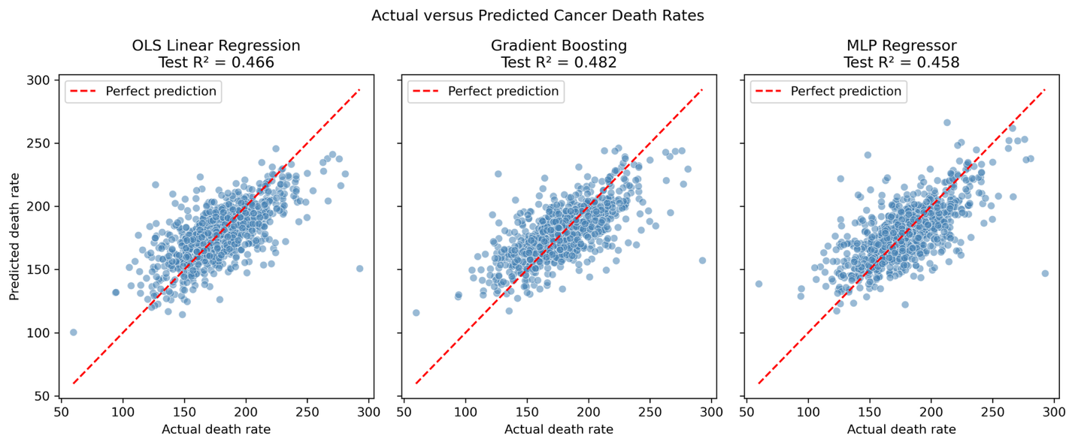
Figure A2
Testing Prediction Errors Across Cancer Regression
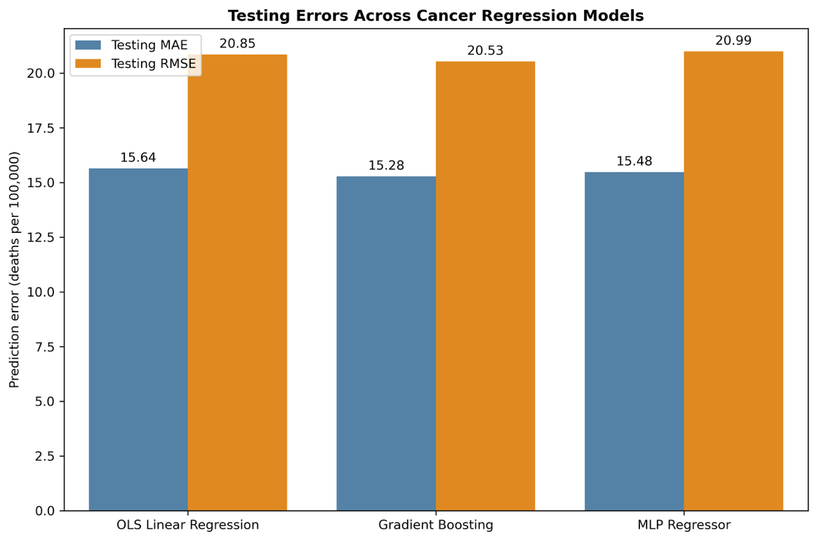
Figure A3
Permutation Importance of Measured Factors in Cancer Mortality Prediction
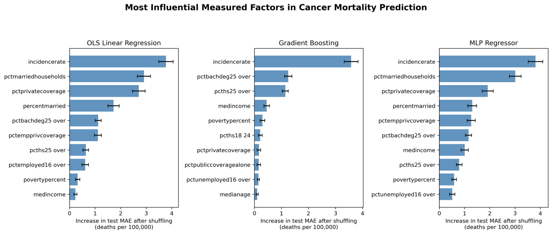
Note: Importance represents the increase in testing MAE after each predictor was randomly shuffled. Larger values indicate greater predictive influence but do not establish causation. Error bars represent variation across permutation repetitions.
Figure A4
Cancer Regression Model Performance Comparison
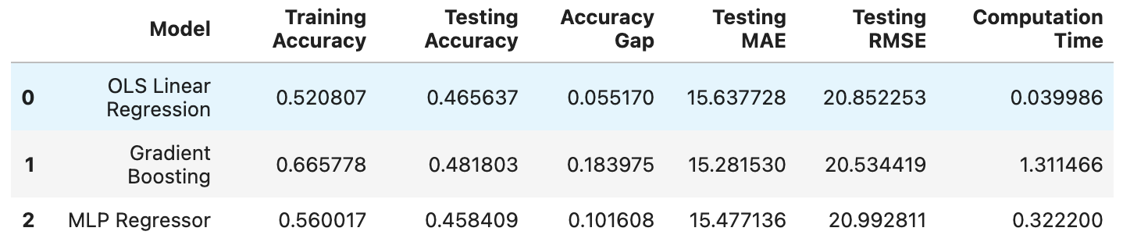
Figure A5
Stroke Classification Model Performance Comparison
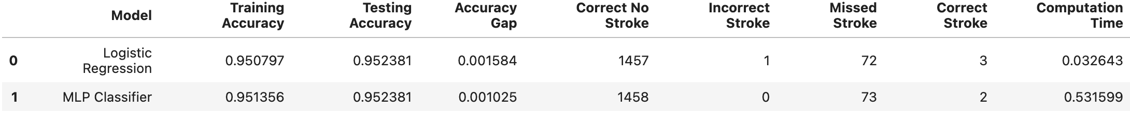
Figure A6
Confusion Matrices for the Stroke Classification Models
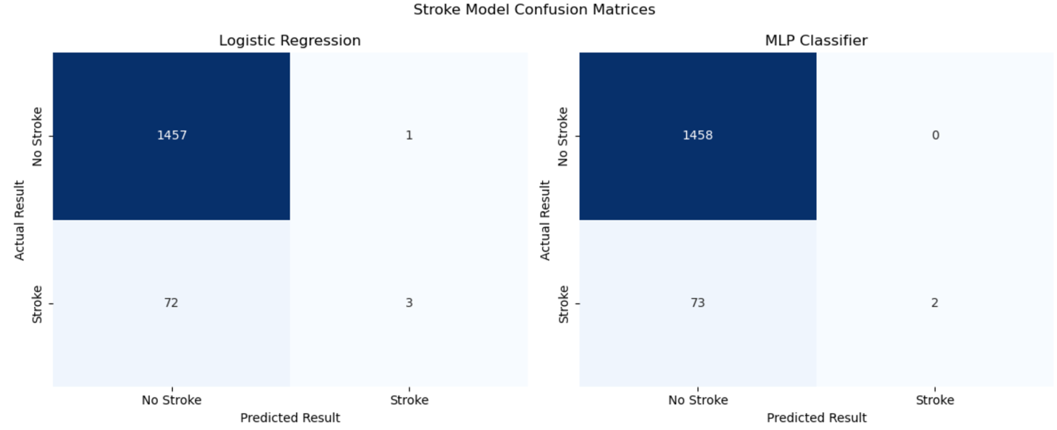
Note: Rows represent actual outcomes, and columns represent predicted outcomes. Stroke predictions were generated using a probability threshold of 0.39.
Figure A7
Permutation Importance of Measured Factors in Stroke Prediction
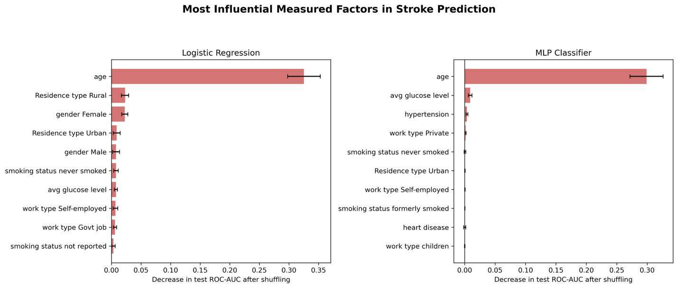
Note: Importance represents the average decrease in testing ROC-AUC after each predictor was randomly shuffled. Larger decreases indicate greater predictive influence but do not establish causation. Error bars represent variation across permutation repetitions.
Figure A8
Distributions of Predicted Stroke Probabilities by Actual Outcome and Model
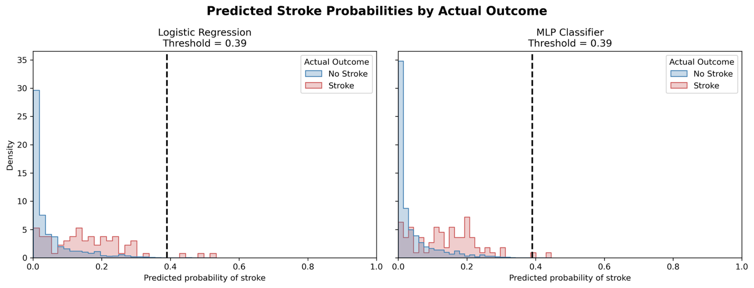
Note. The dashed line represents the selected classification threshold of .39. Probabilities at or above the threshold were classified as stroke. The distributions are displayed as densities and therefore do not represent the substantially different numbers of stroke and no-stroke observations.

